Linked List Example

A good example I see is web-browsers, where it creates a linked list of web-pages visited, so that when you check history (traversal of a list) or press back button, the previous node's data is fetched.

Linked list are usually a basic dynamic data structure which implements queues and stacks and I hope you already know real life example for them.

IBM Pattern Modeling and Analysis Tool for Java Garbage Collector

https://www.ibm.com/support/pages/ibm-pattern-modeling-and-analysis-tool-java-garbage-collector-pmat

Download ga458.jar for garbage collector log analysis

To run the

java -jar ga458.jar

Download ha457.jar, a heap analyzer for heap dump analysis.

To run

java -Xms6G -jar ha457.jar

Java->Process Definition->JVM Settings

To check Verbose GC is enabled

---Before Change

WebContainer Settings: Below setting should not be present

com.ibm.ws.webcontainer.disableStaticMappingCache=*

Restart the server

Run the IN test case for 10m first for warm up and then for 30m

Collect the garbage collector log from both the server and zip it for analysis.

• cd /opt/ibm/WebSphere/AppServer/profiles/app1/logs/OPFClusterApp1

• cd /opt/ibm/WebSphere/AppServer/profiles/app2/logs/OPFClusterApp2

---After Change

WebContainer Settings: Below setting should be present

com.ibm.ws.webcontainer.disableStaticMappingCache=*

Restart the server

Run the IN test case for 10m first for warm up and then for 30m

Collect the garbage collector log from both the server and zip it for analysis.

• cd /opt/ibm/WebSphere/AppServer/profiles/app1/logs/OPFClusterApp1

• cd /opt/ibm/WebSphere/AppServer/profiles/app2/logs/OPFClusterApp2

WAS Console

Trouble shooting:Java Dump-> cd /profiles/test_profile/profile/app1

Problem Context:

This submission service is also being called from the Autosys Job: SUBMISSION_TO_CLEARING which is synchronous. The same job is configured multiple times but with different parameters in the Autosys and that is the reason we can see the objects of BNPPStandardInterchangeSubmitter more than 5.

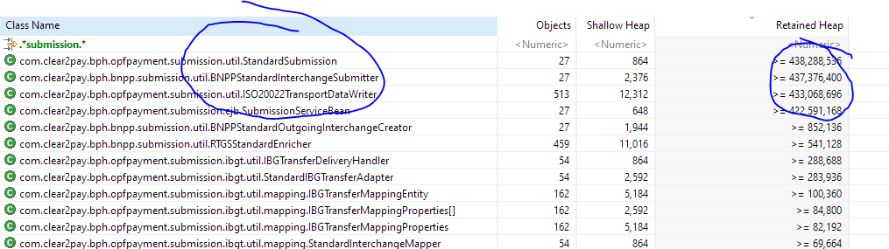

Each instance of  BNPPStandardInterchangeSubmitter in Submission Service contains around 20 objects of ISO20022TransportDataWriter (for every formats ISO20020-RTGS, ISO20020-NEFT, ISO20020-PAYNET etc.) as per the submission-bnpp.xml. Due to this reason, we can see the objects of  ISO20022TransportDataWriter are 513.

This is default behavior of OPF, nothing wrong in this.

Currently I am finding the way to bring down the number of objects ISO20022TransportDataWriter from 20 to 2 or may be 3, it depends on the common configuration.

**Solution**:

Analyzed the Submission service and tried to find the ways to control the creation of objects for BNPPStandardInterchangeSubmitter and its ISO20022TransportDataWriter.

1. Submission Service
   * If we want to throttle the Submission Service then we should introduce the new queue between the Autosys Job and Submission Service
     + **Autosys Job – New Queue(JobSubmissonQ)– Submission Service**
     + Max sessions on this new queue can be configured as 5
2. ISO20022TransportDataWriter
   * Currently we are initializing ISO20022TransportDataWriter for every formats (ISO20020-RTGS, ISO20020-NEFT, ISO20020-PAYNET etc.) as per the submission-bnpp.xml which is containing the duplicate formatter ids in most formats. I have checked the configuration and found that we can have two categories of formatters which can cover all the formats as shown below:
     + With Header
     + Without Header

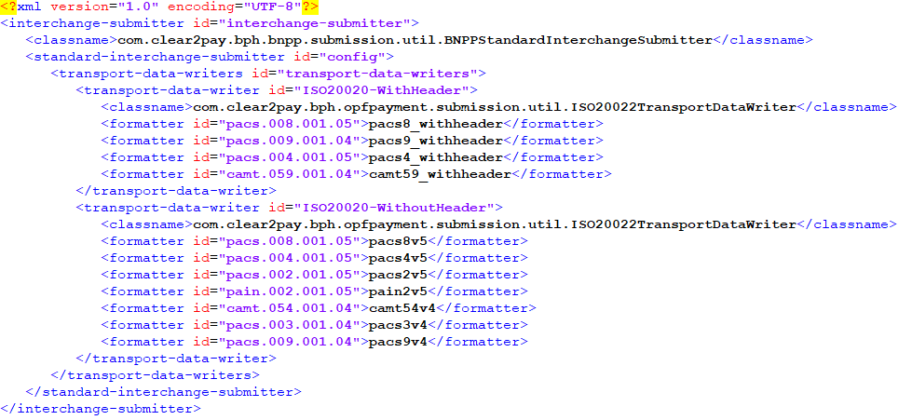

* + If we go with this approach, then we will have only 2 instance of ISO20022TransportDataWriter instead of 20. For example, If we have 5 instance of BNPPStandardInterchangeSubmitter then only 10 instance of ISO20022TransportDataWriter will be created which is 10 times lesser.
  + But this solution can be out of OPF, means we need to override the default behavior of OPF.

1. RTGSStandardEnricher
   * Checked the instances of RTGSStandardEnricher created more than 450. We need to restrict the creation of these objects also but in that case, we need to override the default behavior of OPF in BNPP.